Chapter 9, Solution 9.

(a) 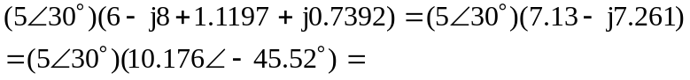

50.88∠–15.52˚.
(b) 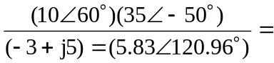 60.02∠–110.96˚.

